**System Design**

**Introduction**

* **System analysis**: The analysis of the designed system is performed here. System analysis includes the complete design of the system. By referring the Software requirement specification document the analysis of the system is performed and the system is designed based on the features mentioned in the software requirement specification document.
* **System design**: Once the system is analyzed, system is designed. The system is designed by including the various features of the system which is mentioned in the SRS document. The system design includes data flow diagram and the content flow diagrams. Using these diagrams, the system architecture is designed as to make it easy for designing the system.

1. **Applicable documents**

The designing of the system is done by referring the features of the software requirement specification document.

1. **Functional decomposition**

The functional components are:

* The customers must register to the website by entering all their details. Once the registration is successful they can login to the web page.
* Customer can update their profile details and also they can change their password details.
* The customers can then purchase the books they wish to read by adding it cart.
* Once the payment is complete, they can view the download the e-books and other books will be delivered to their shipping address.
* The customers can view their purchase report and billing receipt.
* The book seller or the publisher must login to the website using the login details provided by the admin.
* The books of their publications must be added by them along with the price and other details.
* Once the customer purchase the book, the purchase report will be available to the book sellers and they can deliver the book to the shipping address provided by the customer.
* The admin of the web page must add the book sellers and authors.
* The admin can add the different categories of the books. Once the category is added based on the categories the different books can be uploaded by the admin.
* The admin can view purchases done by various customers and also the admin can view the customer details.
* The admin is the one who manages the entire web page and monitors all the users as well as the activities of the web page.

1. **Program description**

**3.1 Data flow diagram**

The data flow diagram is pictorial representation of the flow of data in the system. Through this diagram the communication between various modules of the system is represented. The data flow diagram is very essential because this will let the developer understand the actual picture of the system. The data flow diagram will tell the developers how the coding of the system must be done. This diagram will connect each and every module to one another and makes the system complete.

The data flow diagram is nothing but the flowchart which uses various symbols to represent the modules and processes. The data flow diagram will use the features of the software requirement specification document to draw the diagrams.

**Notations in DFD**

|  |  |
| --- | --- |
| **Symbol** | **Description** |
|  | This symbol is known as circle or bubble. This represents the process. Each process in the DFD must be represented using this symbol. |
|  | The rectangular box represents the sink or source of the system. This box includes the users of the system and the main functionalities of the system. |
|  | A line with arrow this represents the data flow across the system. The data flow is between the processes and the sink or source. |
|  | A parallel line or the open box this represents the tables of the database. The data will be stored in the table of system database will be shown by this symbol. |

**3.2 Context flow diagram**

Context flow diagram is nothing but the data flow diagram itself. In the context flow diagram, the communication between the system and its various utilities are shown. This diagram shows the relationship of the system in brief. In this diagram the representation of the users of the system with the database of the system is shown.

**Context Flow Diagram (Level 0):**

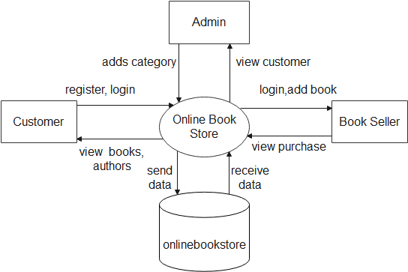

**Top Level: DFD (Level 1**):

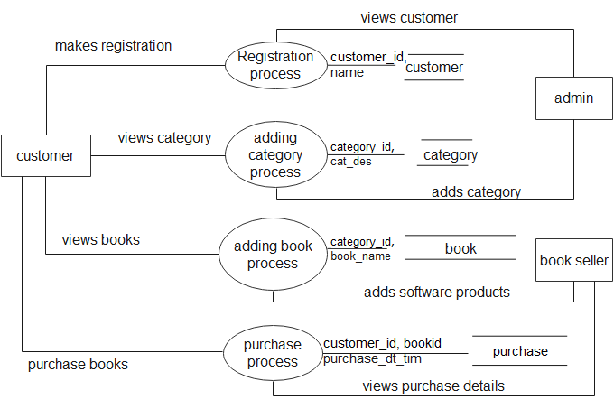

**DFD Level 2:**

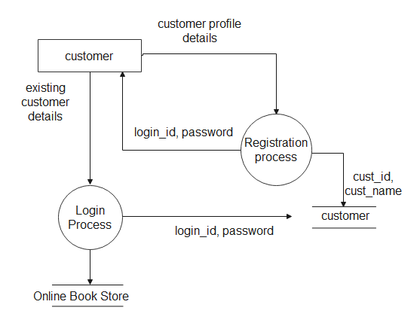

**Description of component:**

* **Input:**
* Customer registration details
* Customer login details
* **Process Definition:**
* Customer registration
* Customer login
* **Output Definition:**
* The customer must make the registration and these details will be stored in the customer table.
* Once the customer registers they can login to the web page using login id and password.

**DFD Level 3:**

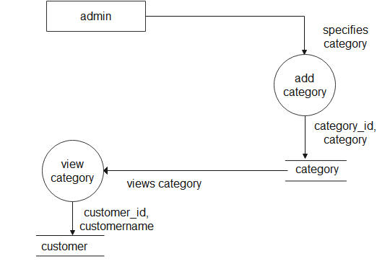

**Description of component:**

* **Input:**
* Category details
* **Process Definition:**
* Adding category details
* Viewing category details
* **Output Definition:**
* The admin can add the category and it will be stored in the category table.
* The customers can view the category under view book category.

**DFD Level 4:**

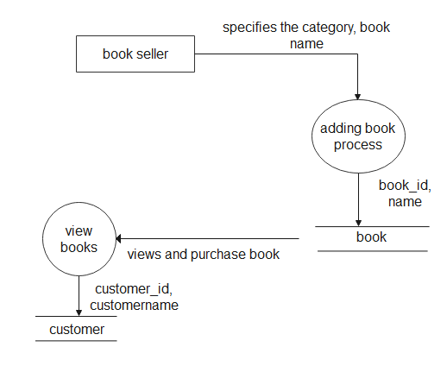

**Description of component:**

* **Input:**
* Book details
* **Process Definition:**
* Adding book details
* Viewing book details
* **Output Definition:**
* The book details are added by the book seller and stored in book table
* The customers can view the books under book category and based on the authors.

**DFD Level 5:**

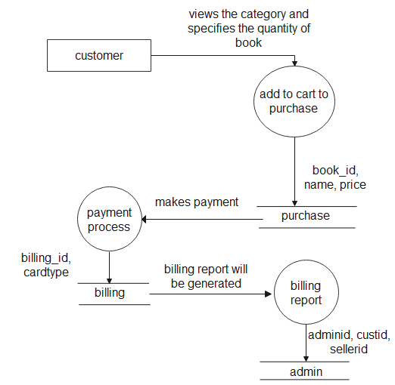

**Description of component:**

* **Input:**
* Purchase details
* **Process Definition:**
* Purchasing book details
* Payment process details
* View billing report
* **Output Definition:**
* The customers can view the book details and add them to cart to purchase.
* The books added to cart will store in the purchase table.
* Once the payment is made book will be delivered to the customer and billing receipt will be generated.
* The admin, book seller and the customers can view the purchase report and billing report. Billing report will be stored in the billing table